1. What is JSON

* JSON stands for **J**ava**S**cript **O**bject **N**otation
* JSON is a lightweight format for storing and transporting data
* JSON is often used when data is sent from a server to a web page
* JSON is "self-describing" and easy to understand

1. What is promises

* A Promise is an object representing the eventual completion or failure of an asynchronous operation. Since most people are consumers of already-created promises, this guide will explain consumption of returned promises before explaining how to create them.

1. Write a program of promises and handle that promises also

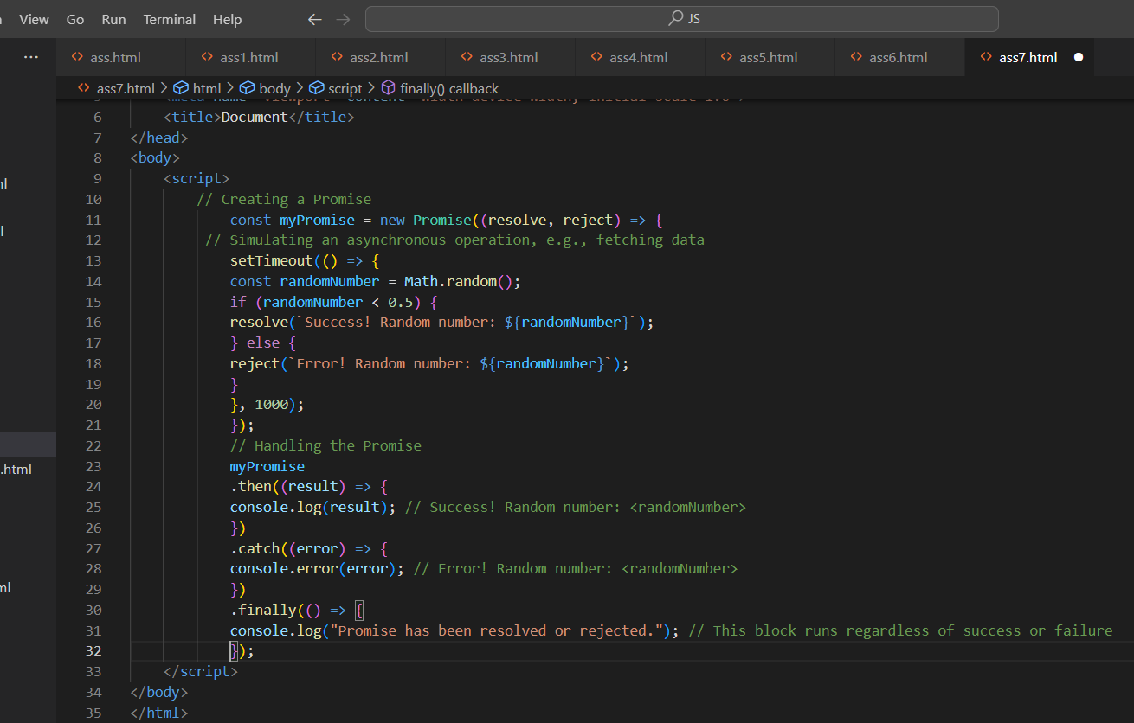

1. Use fetch method for calling an api <https://fakestoreapi.com/products>

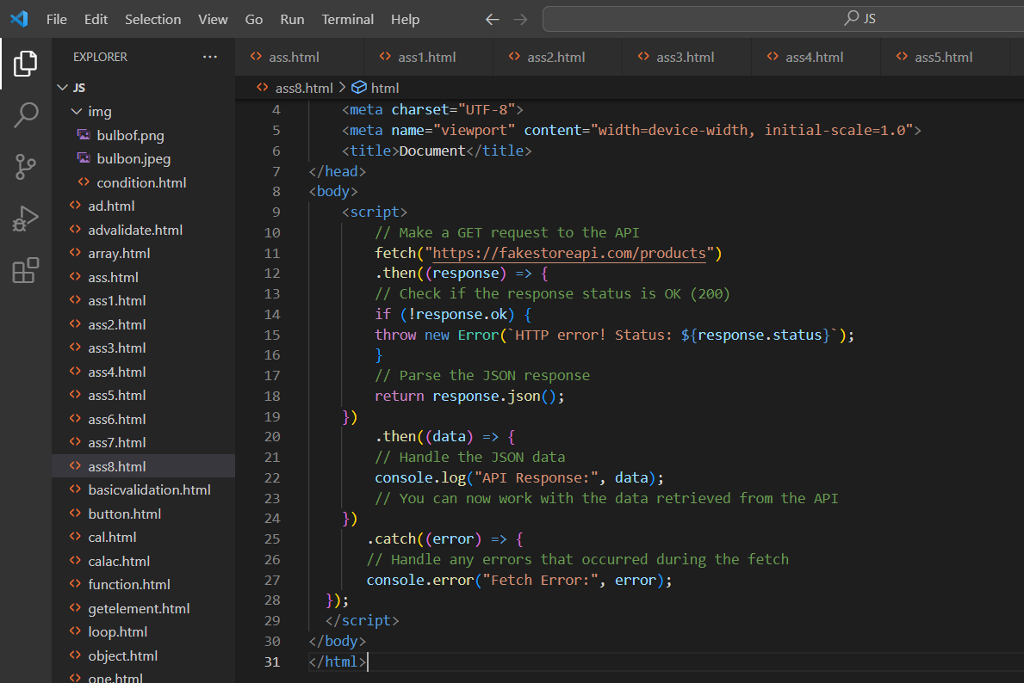

1. Display all the product from the api in your HTML page

